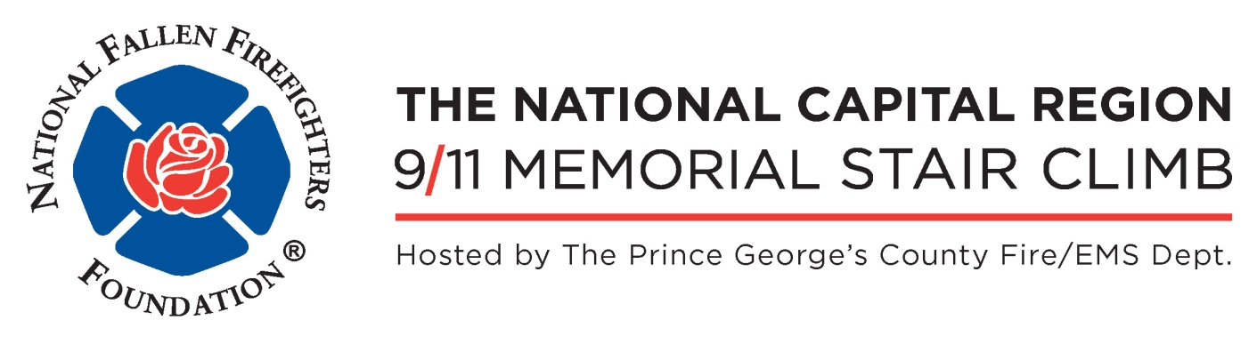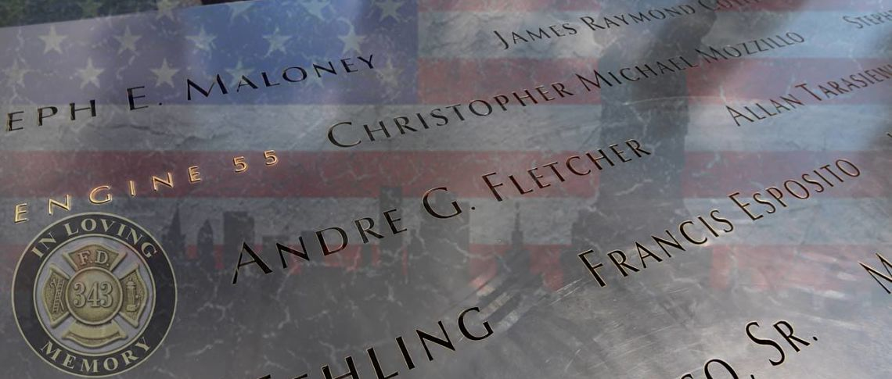
WHEN
Saturday, September 16, 2017
Registration: 0600
Climb Start: 0847

WHERE
Gaylord National Resort & Conference Center
National Harbor, Maryland

COST
$35, includes T-Shirt & challenge coin for the first 343 to register

REGISTER ONLINE
http://events.firehero.org/pgcounty

The National Capital Region 9/11 Memorial Stair Climb/5K Walk

The Stair Climb and 5K Walk are not races, but an opportunity to honor and remember the 343 FDNY firefighters who selflessly gave their lives so that others might live on 9-11-2001. Through firefighter and community participation we can ensure that the world knows that we will never forget.
The Stair Climb and 5K Walk benefit the FDNY CSU and the programs provided by the NFFF to support the families of our nation’s fallen firefighters.

